FULL TITLE OF THE PAPER (12-point TNR +bold) in English
FULL TITLE OF THE PAPER (12-point TNR + unbolded) in English
Name Surname¹, Name Surname²
1) Affiliation (country, university, faculty, e-mail)
2) Affiliation (country, university, faculty, e-mail)
Notice! Use only Latin alphabet, please.
Abstract in English (maximally 200 words). The abstract should refer to each part of the paper, i.e. introduction and the purpose of research, research materials and test methods used in the paper, and the most important findings and conclusions. It is necessary to use all keywords in the abstracts (it will make it easier for the interested to find the paper).

Keywords: (maximally 6 words in English)

Abstract in Polish (maximally 200 words). The abstract should refer to each part of the paper, i.e. introduction and the purpose of research, research materials and test methods used in the paper, and the most important findings and conclusions. It is necessary to use all keywords in the abstracts (it will make it easier for the interested to find the paper).

Keywords: (maximally 6 words in Polish)

Introduction

The paper itself should consist of the following parts: Introduction, Materials and methods, Findings and discussion, Conclusions, References. The article should be 10-15 page long in the A4 format (including tables, figures, references and abstract). The text should be written with 12-point Times New Roman (TNR), 1.5 line spacing, with automatic hyphenation in Polish. Do not use underlining.
Please, follow the APA style (www.apastyle.org) when citing other authors’ publications. See the instruction below:
- Verbatim quotations: (Kowalski, 2012, p. 27)
- Indirect quotations (paraphrases or summaries): (Kowalski, 2012)
- Should you refer to a number of works by different authors, please organise them in the chronological order: (Kowalski, 2011; Nowak, 2014; Skalski, 2017)

Materials and methods

Normal text. Normal text. Normal text. Normal text. Normal text. Normal text. Normal text. Normal text.

Findings and discussion

Normal text. Normal text. Normal text. Normal text. Normal text. Normal text. Normal text. Normal text (Table 1).

Table 1. Range of variations in selected features in 2016-2018 (12-point TNR)
Name  of the country | Value of the coefficient |  |  | Value of the indicator  in 2017
Name  of the country | 2016 | 2017 | 2018* | Value of the indicator  in 2017
Poland | 89.2 | 105.6 | 125.6 | 0.92
Germany | 103.8 | 111.0 | 114.8 | 0.96
France | 112.3 | 113.6 | 128.7 | 0.97
Great Britain | 116.8 | 129.8 | 142.8 | 0.91
*, forecast
Source: Statistical Yearbook of the Republic of Poland 2017. Central Statistical Office (GUS), Warszawa, p. 254. (10-point TNR, normal)

Normal text. Normal text. Normal text. Normal text. Normal text. Normal text. Normal text. Normal text (Figure 1).

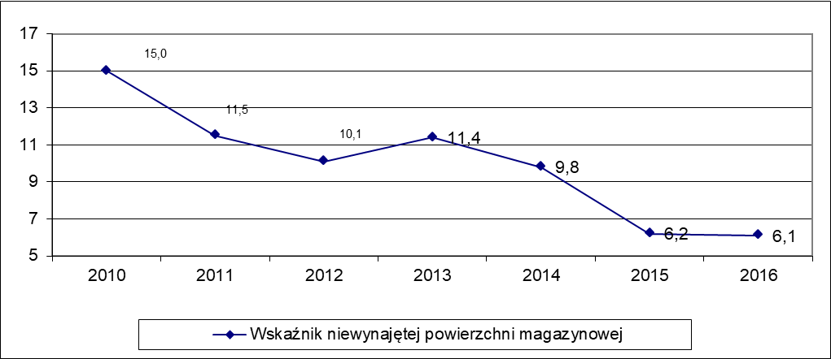

Figure 1. Caption for the figure (12-point TNR, normal)
Source: own calculation on the basis of research results. (10-point TNR)

Normal text. Normal text. Normal text. Normal text. Normal text. Normal text. Normal text. Normal text.

Conclusions

Normal text. Normal text. Normal text. Normal text. Normal text. Normal text. Normal text. Normal text.

Reference list (maximally 25 items)

Griffin, R.W. (2017). Podstawy zarządzania organizacjami. Warszawa: Wydawnictwo Naukowe PWN.
Kardas, J.S., Wójcik-Augustyniak, M. (Eds.). (2017). Zarządzanie w przedsiębiorstwie. Środowisko, procesy, systemy, zasoby. Warszawa: Difin.
Kowal, N. (2012). Wspólna odpowiedzialność. Retrieved from http://odpowiedzialnybiznes.pl/Wspólna-odpowiedzialność.pdf.
Podstawka, M., Świrska, A. (2015). Optymalizacja wpływów do budżetów gmin z tytułu subwencji wyrównawczej. Zeszyty Naukowe UPH w Siedlcach nr 106. Seria: Administracja i Zarządzanie (33)2015, 173-184.
Szajczyk, M. (2017). Zarządzanie projektami. In J.S. Kardas, M. Wójcik-Augustyniak (Eds.), Zarządzanie w przedsiębiorstwie. Środowisko, procesy, systemy, zasoby (pp. 358-364). Warszawa: Difin.

CORRESPONDENCE ADDRESS
Name and surname (1st author)
Affiliation:
Full address: country, city, street, building number, postcode
Phone: +48 000000
e-mail: exampe@example.pl

Name and surname (2nd author)
Affiliation:
Full address: country, city, street, building number, postcode
Phone: +48 000000
e-mail: exampe@example.pl

